

Building Research Questions
This worksheet can be used to draft research questions for a library assessment project.

Investigating Connections
Oftentimes, library assessment research questions are designed to explore connections between a current or anticipated library service, resource, or space and the outcome that the library service, resource, or space is intended to achieve.
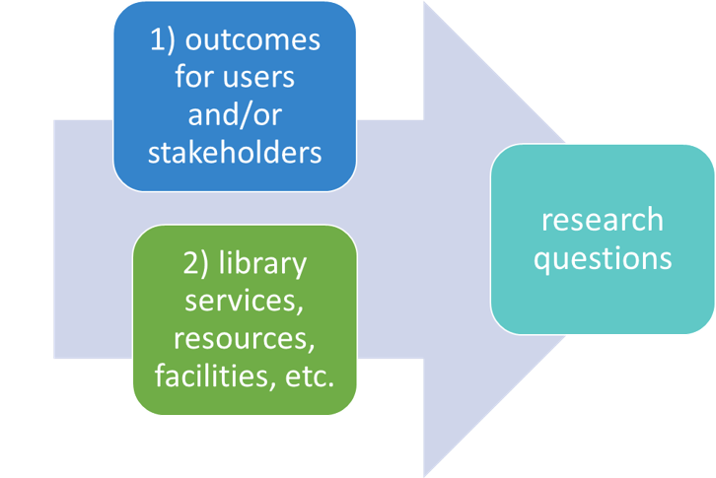
For such an assessment focus, answering the following questions is useful in framing the overall project.
- What outcome for users, not-yet users, stakeholders, partners, or colleagues is the focus of the assessment project at hand?
- What library service, resource, or space is the subject of the assessment project at hand?
- What possible connections or linkages between #1 and #2 might be useful to understand? What verbs might be helpful in articulating those possible connections?
- Impact?
- Contribute to?
- Affect?
- Influence?
- Relate to?
- Cause?
- Determine?
- Help?
- Correlate with?
- other:

Drafting Research Questions
Once the outcome, library offering, and potential connections are clarified, the following chart can be used to draft initial library assessment-focused research questions.
Library Service,  Resource or Space | Relationship Verb | Intended Outcome
Does [library service, resource, or space] | relationship verb | outcome
In what ways does [library service, resource, or space] | relationship verb | outcome
To what extent does [library service, resource, or space] | relationship verb | outcome
How does [library service, resource, or space] | relationship verb | outcome
Example: In what ways does the reference desk (physical, virtual, or other) | contribute to | improved student learning or assignment grades?

Checking Drafted Questions
Once a research question has been drafted for an assessment project (using the process above or some other means), library assessment practitioners might wish to explore the following questions.
- Is the question worth answering? Why? What is the purpose of answering it?
- What evidence, data, or other information will help answer the question? How can you obtain/access that information?
- What do other studies that answer this question include or look like?
- What research methods would yield the evidence, data, or other information you need? What are the advantages and disadvantages of each research method you are considering? Might multiple methods be used in tandem?
- What user groups, partners, collaborators, or stakeholders should be involved?
- What do you expect to result from this assessment?
- Who will need or want to know about the results? How do you expect them to act on the results?

