Developing User Stories
This worksheet can be used to draft user stories for a library assessment project.

Investigating Connections
User stories are tools used to design systems, but they also can be used to scope library assessment projects. Generally speaking, user stories describe who a user is (e.g., user, not-yet user, stakeholder, partner, colleague), what the user needs/wants to accomplish, and why that accomplishment (i.e., outcome) is desirable.
User stories can be formatted in a number of ways, including:
- As [who], I want [what], so that [why].
- As a [user], I want [goal] so that [reason].
- As [stakeholder], I want [to be able to do an activity, to have an awareness, to take an action] in order to [achieve outcome, solve problem, meet need].
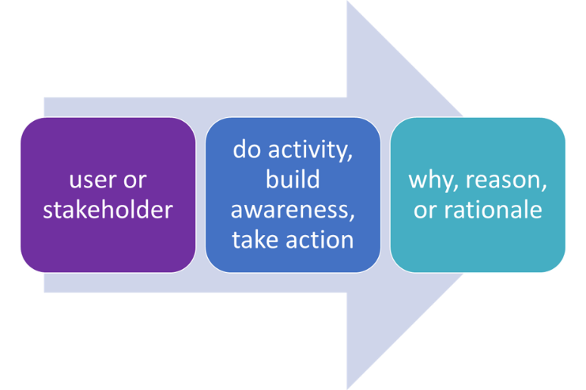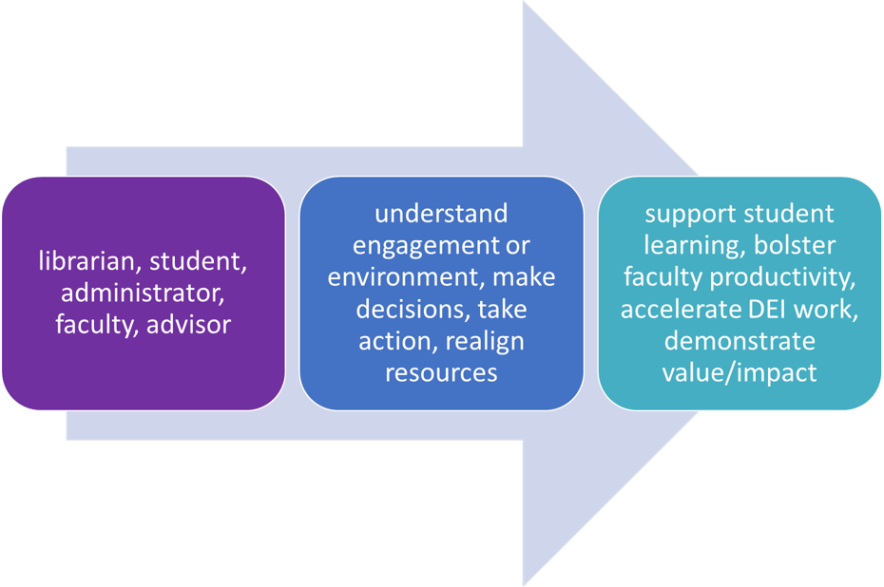

To employ user studies in a library assessment project, answering the following questions is useful in framing the overall project.
- Who is the user that is the focus of the assessment project at hand? Users might include students, librarians, faculty, advisors, institutional researchers, administrators, or other user groups, partners, stakeholders, or decision makers. Users can be narrowly or broadly defined, as appropriate for a give project and focus.
- What does the user want or need to do? This might include increasing understanding or engagement, improving environments, growing the ability to do an activity, building awareness, accomplishing tasks, etc.
- Finally, why does the user want or need to do this thing? Rationales articulate goals and aims, including achieving outcomes, solving problems, and meeting needs.
Once these three elements of a user story are clarified, the following chart can be used to draft initial library assessment-focused research questions.
User  (who) | Action User Wants to Complete  (what) | Rationale/Purpose for Accomplishing the Action  (why)
Example: As a librarian, | I want to know whether students who engage with library reference services earn better assignment grades | so that I can encourage more faculty and students to interact with reference librarians and generally improve and customize reference services.
As assessment projects can serve a number of users and needs simultaneously, it is likely that a complex library assessment project may be guided by multiple user stories.

